Photo resister
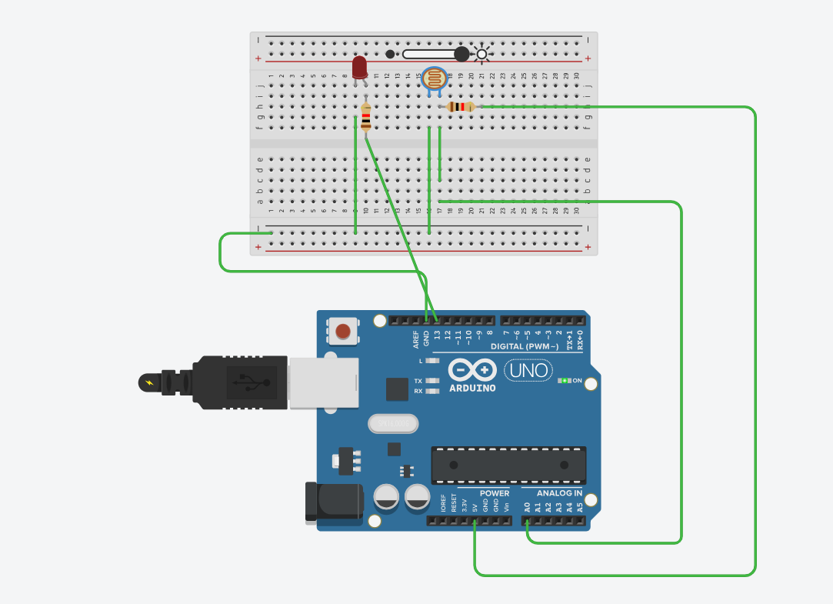
const int ldrpin = A0;
const int ledpin = 13;
int threshold = 500; // fixed: changed comma to semicolon

void setup() {
pinMode(ledpin, OUTPUT);
Serial.begin(9600);
}

void loop() {
int val = analogRead(ldrpin);
Serial.println(val);

if (val > threshold) {
digitalWrite(ledpin, HIGH);
} else {
digitalWrite(ledpin, LOW);
}

delay(200);
}

